Website Proposal

Table of content
- Introduction
- Scope of work
- Purpose
- Site and domain names
- Features
- Sitemap
- Web Log
- Contact us form
- Website Gallery
- Events and News system
- Security System
- Events, Forum and Active Web Design
- The Content accordingly
- Services Provided
- Maintenance
- Additional site changes
- The Project Duration
- Financial Statement
- The Warranty
- Expected Project Calendar
- General Condition
- General agreement

Introduction
This proposal is intended to describe the work scope of building a website for the “”

Scope of work
The scope of work is to build a website for the “”. The website will be in one language (Arabic), please note that the illustration included hereinafter show Arabic language and if there is another language, the same concept will be applied on the other language. And the website will be compatible with IE 7, 8, 9 and the latest version of Firefox and chrome and Safari from the date of approved offer.

Purpose
The objective of this website is to promote the full advantages of “” to customers.
The site will give easy to access information to all users and enable them to find easy and smart way for data access.

About Us

“MNSS” combines over 5 years of expertise through its highly energetic and exceedingly creative staff of professionals.
MNSS help you to create a strong brand, messages and strong agendas for your organization so it can compete in today’s cut throne markets.
MNSS also believes in putting its clients first. This is why it invests in highly trained professionals to handle accounts from start to finish.
From the beginning, a relationship based on trust is established, thus it perform and operate in a way that keeps clients at ease, from beginning to end.
MNSS focus on two important elements, the first is to present high quality work, second is commitment with deadlines.
So let us offer our services:
- Graphic Design.
- Campaigns Productions.
- Media Press.
- Media Plans.
- Printing Services
Tel. / Fax : 00962 6 5690872
Email: info@MNSS.co

Site and domain names
The system will be able to provide customers with registered domain and ability to add many numbers of subdomains to satisfy users’ needs.

Features
The features and modules are listed below with description:
Feature | Description
Web design | Theme: look and feel for brand
Pages and menu builder | Allow system users to add unlimited HTML pages and add/Edit images and text content.
News | Will keep the website visitor updated with the latest news, can also keep them updated with news that might be of interest to them.
Photo Gallery | Allow system uses to manage and categories the photos which can display in different views for website visitors
Events | Will keep the website visitor updated with the latest Events.
Marquee | Marquee for latest news.
Poll and voting | Poll and voting for web site and each article in the site
Search | Search engine in website pages.
Contact us | Contact us form.
Member list | Allow system administrator to manage the website subscribers (used for newsletter).
Dynamic CSS Management | Allow system users to manage CSS files dynamically.
Site Map | Site map for website pages
SEO | Search engine optimization using latest tools and features.

Sitemap
The proposed site map is to improve the website, especially when the web site is in development phase. The changes in development phase will discuss more in the project forum.
Web Log
Web log is a visitors’ statistic. Our design will include a visitor statistic report. This is essential for internet traffic planning. The report will be included in our web administrator application package. See sample screen below which show web log for the website, this report will increase information’s about interested people groups and areas so site admin can focus on that area, also our design will user Google Analytics.
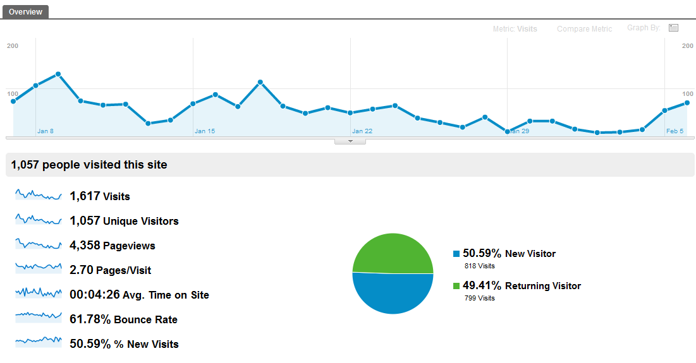

Contact us form
Contact us form is a very important form for your internet business. It is the one of the most effective way for people can contact you. Hence we provide you with a database and web application to monitor and reply to your contact form.
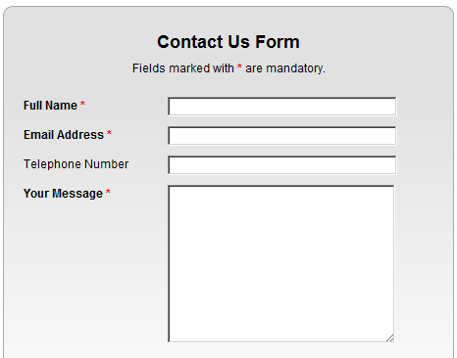

Website Gallery

The website will contains photo and video gallery to show all required information’s as below:
- Image gallery
- Video gallery

Events and News system
The system will provide end users with latest articles and news and also admin panel will enable administrator to update news easily at any time.
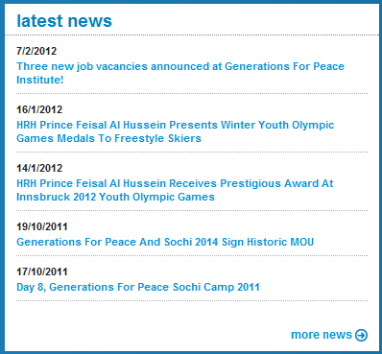

Security System
The system will enable users to add, edit and delete users with full controls to their access list and roles all that will done through the admin panel.
So the system will enable to customize user permission and roles for each user to keep the items highly secured from users and to customize the control procedure.

The Content accordingly
- Design concept
- The site will be built with importance placed on the notions of contrast, simplicity and impact.
- Attractive design will be implemented to meet high level of quality.

- Description of the site
- An official site for Test which will provide information about the company’s profile, company’s vision, products, and support.
- The page design will offer a balance in between the text and surrounding space.
- Navigation system will be of highly sophisticated and achieved by the use of page-selecting pull down menus, well-constructed local navigation, search box, and other effective features.
- The images used in the navigation sections will be as simple as possible. In fact with the skillful integration of the style sheet, the design will allow optimal download speeds.
- With the dynamic design of the site, it will help in contributing the wide recognition of the products

- Newsletter System
- Articles and News system.
- Security System.
- Site Gallery
- The gallery will display all available products of the company with below format
- Ajax Photo slider.
- Description of the product.
- Small video player to show product details.
- Search criteria to search available products.
- Real State Item search
Please see below URL as sample site
http://www.generationsforpeace.com

Services Provided
- Professional SEO service
Search engine optimization (SEO) is the process of improving the volume and quality of
Traffic to a web site from search engines via "natural" ("organic" or "algorithmic") search results.

SEO efforts may involve a site's coding, presentation, and structure, as well as fixing
Problems that could prevent search engine indexing programs from fully spidering a site.

Effective SEO may require changes to the HTML source code of a site, SEO tactics will be incorporated into all mbwebcreator.com web site development and design to make sure the web site is "search engine friendly".

- Email hosting
Email address is included with our hosting plan. If you are hosting with other party, you may have the email hosting from the third party.

- Standard web application
We include 5 very crucial web application forms into our design.
- Contact us form with database
- User statistic log
- express web management system
- Product Gallery.

Maintenance
We provide a four-week testing period after the site launch. During this time any technical issues will be resolved at no cost. After this period, obligations under the contract will be deemed fulfilled and the contract concluded. The web project portal will remain open for customer to update us for any changes.

Additional site changes
Any changes to the website following the testing stage and conclusion of the contract will be charged separately we offers a hosting and maintenance package which will accommodate basic changes to the site (text and project photos) at any time.
The Project Duration
 | Phase Name | Description | Duration | Result | Approval Type | Notes
1 | Offers | Through this phase I will give offer and plan for developing the website in addition to estimated cost of the project | 3 days | waiting | Requires customer approval | Once the offer is approved we will move to the next phase
2 | Design | Through this phase I will prepare the design of the layout pages of the website and make professional look for the website | 5 working days |  | Requires Customer approval | Once the design is approved we will move to the next phase with give me all the required content for the website
3 | Website code development | Through this phase I will develop the user side and the programming pages of the site | 15 working days |  | 90% of the website content | Once the website code is complete we will move to the next phase
4 | Uploading and configuration | Through this phase I will upload and configure the website online | 1 day |  |  | I need the access to the FTP once I finished upload I will start the next phase
5 | Testing and stabilizing | Through this phase I will test the website in the real environment | 3 working days |  | Requires customer approval | This phase will include the customer’s final approval on the website
6 | Closure | This phase will contain a review for all the website and any needed adjustment | 5 working days |  |  | This phase was added as a risk margin for the project delivery

Financial Statement

Item Name | Unit Price | Final Price
One langue |  | 2500 JOD
Total |  | 2500 JOD

The Warranty
I’m warranty obligations are limited to the terms set forth below:
I’m warranty the website delivered to the company/organization mentioned hereinbefore for a period of one month in term of code defect, unstable data transaction and/or any other defects resulted and caused by bad/improper code development. However, I don’t warranty any –but not limited to- errors resulted from bad usage and/or machine malfunction and/or technical failure in hosting company. The warranty of the project is also affected by any terms listed in the general condition section mentioned hereinafter.

General Condition
- The duration of the project will start immediately after receiving all the data needed and right after the final approval of the design and the technical document.
- The website development will start at the time the design is fully approved and I receive the website content in Arabic.
- The website development will start according to the schedule shown before.
- Payments shall be 50% of the cost after offer approval. And the other 50% after the delivery of the site after the testing and stabilizing stage and before closure phase.
- All the approvals and correspondences must be sent through emails or written format.
- The Company has the copy right on the design and ability to take the source file (Photoshop file format) of the template design.
- The offer doesn’t guarantee any error that may occurs as result of Hosting company.
- We highly advise to use Network solutions or Arvixe.com to host the website or to use local Server to handle that issue.
- Any change after the warranty and acceptance it will be charged as change request and will be charged according to its wideness.

General agreement
We will create an Internet website for Client (the “”) in accordance with the terms and conditions mentioned above.
By signing this Agreement, Client acknowledges that they are purchasing the items in this proposal and have read and agree to the terms and conditions above.

